**Terraform Assignment : 01**

**Q. Create a vpc, subnet, internet gateway, route table and then launch an ec2 instance inside a subnet then install apache httpd and access it through port no.80 with the help of terraform**

Step-1: Launch ec2 instance and install terraform

Step-2: Create a directory

* mkdir velocity
* cd velocity
* vi main.tf

provider "aws"{

region = "ap-south-1"

access_key = ""

secret_key = ""

}

###########Creating vpc#############

resource "aws_vpc" "test"{

cidr_block = "10.10.0.0/16"

tags = {

name = "vpc-a"

}

}

###########Creating subnet##########

resource "aws_subnet" "subnet1"{

vpc_id = "${aws_vpc.test.id}"

cidr_block = "10.10.1.0/24"

availability_zone = "ap-south-1a"

tags = {

Name = "Public_subnet"

}

}

resource "aws_subnet" "subnet2"{

vpc_id = "${aws_vpc.test.id}"

cidr_block = "10.10.2.0/24"

availability_zone = "ap-south-1b"

tags = {

Name = "Private_subnet"

}

}

###########Creating Igw##############

resource "aws_internet_gateway" "test_igw"{

vpc_id = "${aws_vpc.test.id}"

tags = {

Name = "igw"

}

}

#########creating route table###########

resource "aws_route_table" "publicrt"{

vpc_id = "${aws_vpc.test.id}"

route{

cidr_block = "0.0.0.0/0"

gateway_id = "${aws_internet_gateway.test_igw.id}"

}

tags = {

Name = "public rt"

}

}

#########route table association#########

resource "aws_route_table_association" "public-1"{

route_table_id = "${aws_route_table.publicrt.id}"

subnet_id = "${aws_subnet.subnet1.id}"

}

resource "aws_route_table_association" "public-2"{

route_table_id = "${aws_route_table.publicrt.id}"

subnet_id = "${aws_subnet.subnet2.id}"

}

#########Security Group###########

resource "aws_security_group" "sg" {

vpc_id = "${aws_vpc.test.id}"

ingress {

description = "SSH from VPC"

from_port = 22

to_port = 22

protocol = "tcp"

cidr_blocks = ["0.0.0.0/0"]

}

ingress {

description = "HTTP from VPC"

from_port = 80

to_port = 80

protocol = "tcp"

cidr_blocks = ["0.0.0.0/0"]

}

egress {

from_port = 0

to_port = 0

protocol = "-1"

cidr_blocks = ["0.0.0.0/0"]

}

tags = {

Name = "allow_ssh_http"

}

}

###########aws instance############

resource "aws_instance" "web" {

ami = "ami-0d1e92463a5acf79d"

instance_type = "t2.micro"

subnet_id = "${aws_subnet.subnet1.id}"

key_name = "linux-kp"

security_groups = [aws_security_group.sg.id]

user_data = <<-EOF

#!/bin/bash

sudo yum install httpd -y

sudo systemctl httpd start

echo "<h1>Learning Terraform</h1>" /var/www/html/index.html

EOF

tags = {

Name = "web_instance"

}

}

######Elastic-ip########

resource "aws_eip" "my_eip"{

instance = aws_instance.web.id

}

* vi output.tf

output "public_ip"

{

value = aws_instance.web.public_ip

}

Step-3:

* terraform init
* ls -ltra
* terraform plan
* terraform apply –auto-approve

1. ec2 instance created inside a vpc

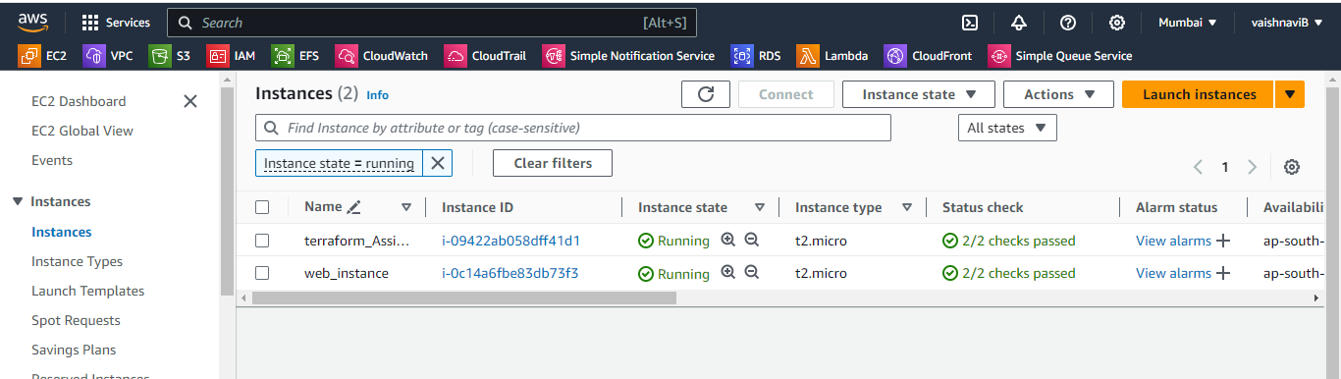

1. eip created

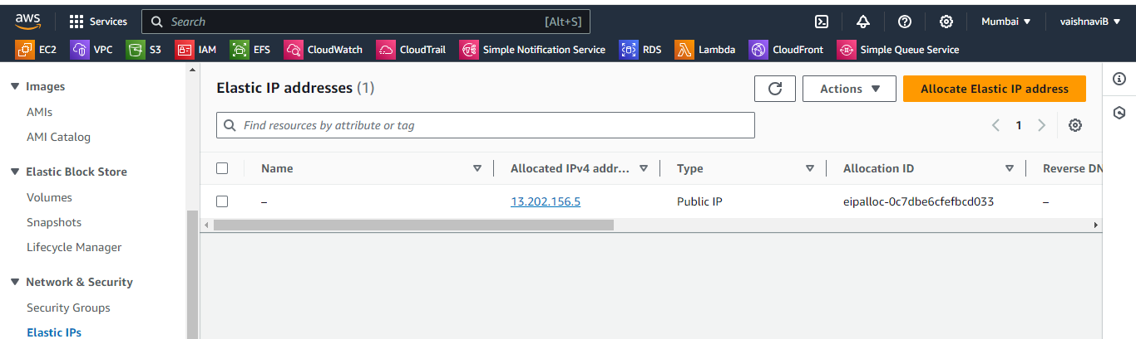

1. vpc created 10.10.0.0/16

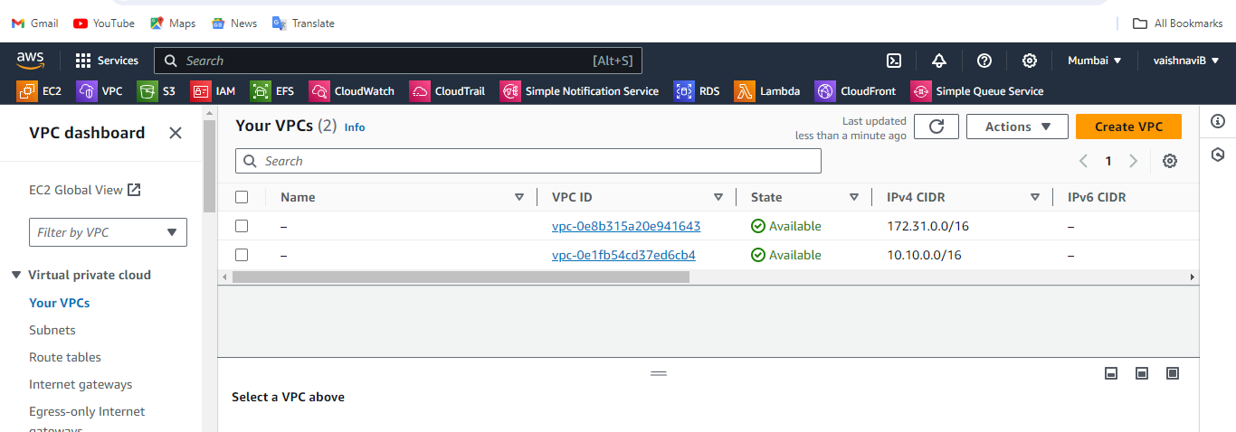

1. subnet created

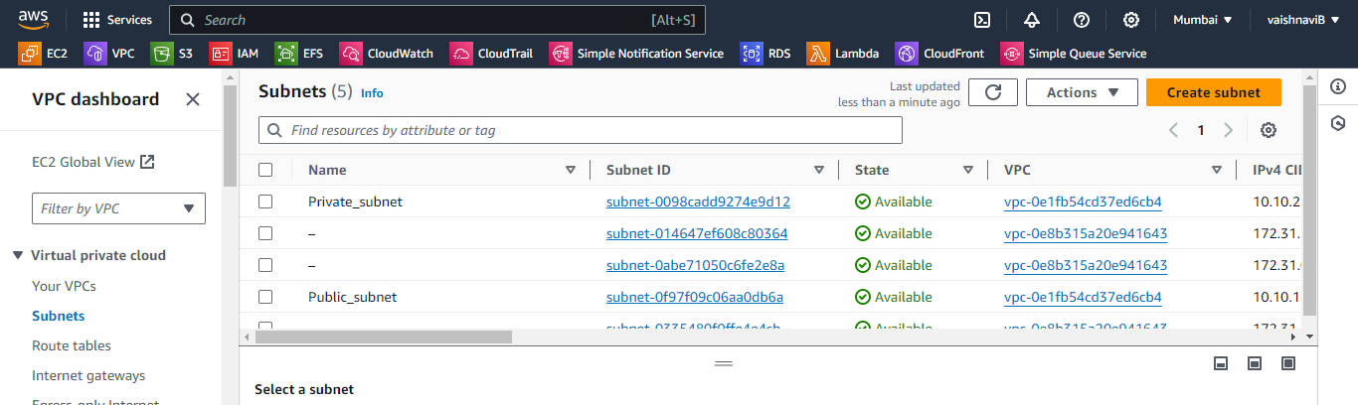

1. Route table created and subnet association is also done

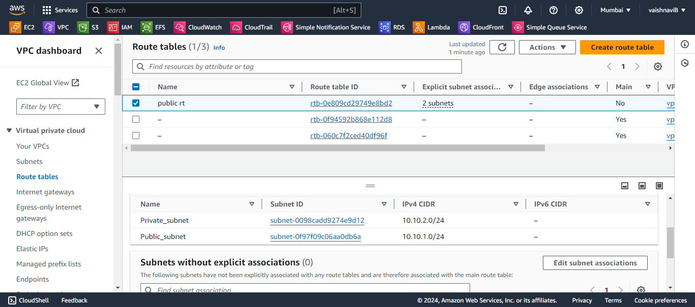

1. InternetGateway created

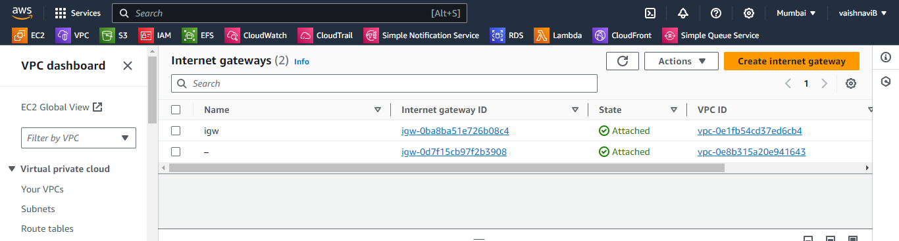

1. Apache httpd index file accessed

